

Dublin Business School

**MSc. Information Systems with Computing**

**Web and Mobile Technologies**

Develop a responsive web application, optimized for mobile, tablets and desktop devices

***FitZone***

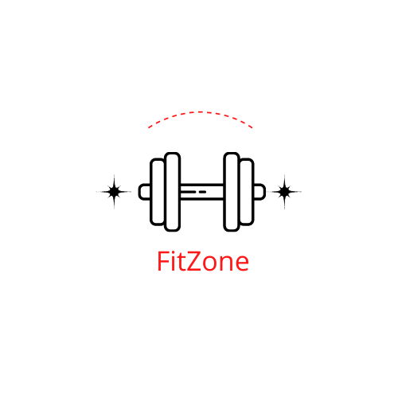

**Lecturer**  : Ehtisham Yasin

**Submitted on** : 15.11.2022

**Presented by** : Nabil El Fadel, Binny Maharjan

**E-Mail** : 10625286@mydbs.ie, 10627073@mydbs.ie

**Student ID** : 10625286, 10627073

# 1. Introduction

: Name, why name and scenario of the project

3,4

For this project, we have to create

While working in a team, there were many types of complications as we both had our different visions and ideas. To solve this problem, we collaborated on our ideas and suggestions together which helped us to create a responsive website. We both took references from other websites and discussed what was good for us.

**Approach to the problem:**

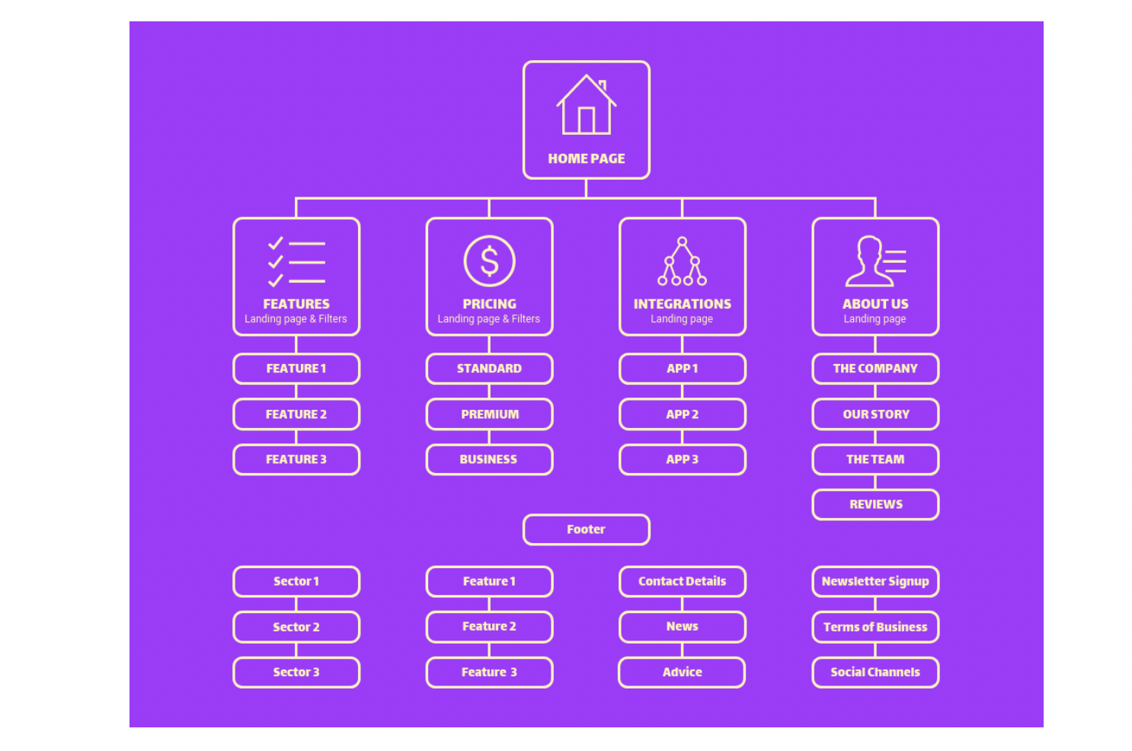

We will divide section of our fitness equipment website into main navbar, header and a footer. For the main navbar we will have two individual webpages. The first webpage contains all the fitness equipment, which provides detailed In order to give users an accurate idea of the fitness equipment, we will use videos and pictures for demonstration. For the second webpage will be a shopping cart offered. In it, the user can reserve all the fitness equipment that has been selected and purchase it afterwards. Reservation for individual equipment is enabled with the help of JS. On the main page, a search bar will be integrated in the navbar, so that the user can search all devices.

Our website should be usable for all devices and accordingly become a responsive website.

**Approach for the layout:**

For our fitness equipment website we will take inspiration from the website “Fitness equipment Ireland”. We try to make the layout similar because it is very straight forward and designed to be user friendly.

Our website *Fitzone* offer ten items/ fitness equipment. On the main page

For the design of the website, we made blueprints of the website in the beginning. We roughly drew how the website will look on paper, then we implemented it on Figma and after looking at that, we did code according to the blueprints. This helped us to set how our website will look in future.